Intelligent Paste Strength Tester
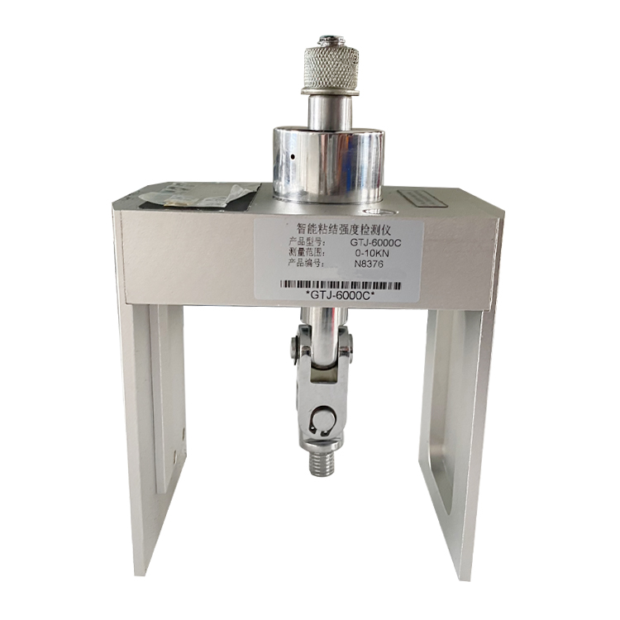

Application
It is suitable for the testing of the pulling force of the rivets, the bonding strength of the wall insulation materials and the bonding strength of the exterior wall facing bricks, all kinds of plates and paints.
Feature
- Light alloy body, s-type tension sensor, high precision.
- Embedded digital tension meter.
- With clear, peak, storage, backlight and other functions.
- Ultra-low power design, no operation automatic shutdown, continuous working time can exceed 200 hours.
- Two measurement modes: strength (MPa) and force value (KN).
Technical Parameter

Item | GTJ-2000A | GTJ-6000C
Instrument structure | Split | Integrated
Measuring range | 0-6.000kN/3.75Mpa
Display mode | kN/Mpa adjustable
Resolution | 0.001kN
Hollow oil cylinder stroke | 10mm
Data storage | 500
Data query and deletion | yes
Peak hold function | yes
Night lighting function | yes
Polyline correction | 10 steps
Body material weight | Stainless steel material 4.5kg | Alloy materials 2.0kg

