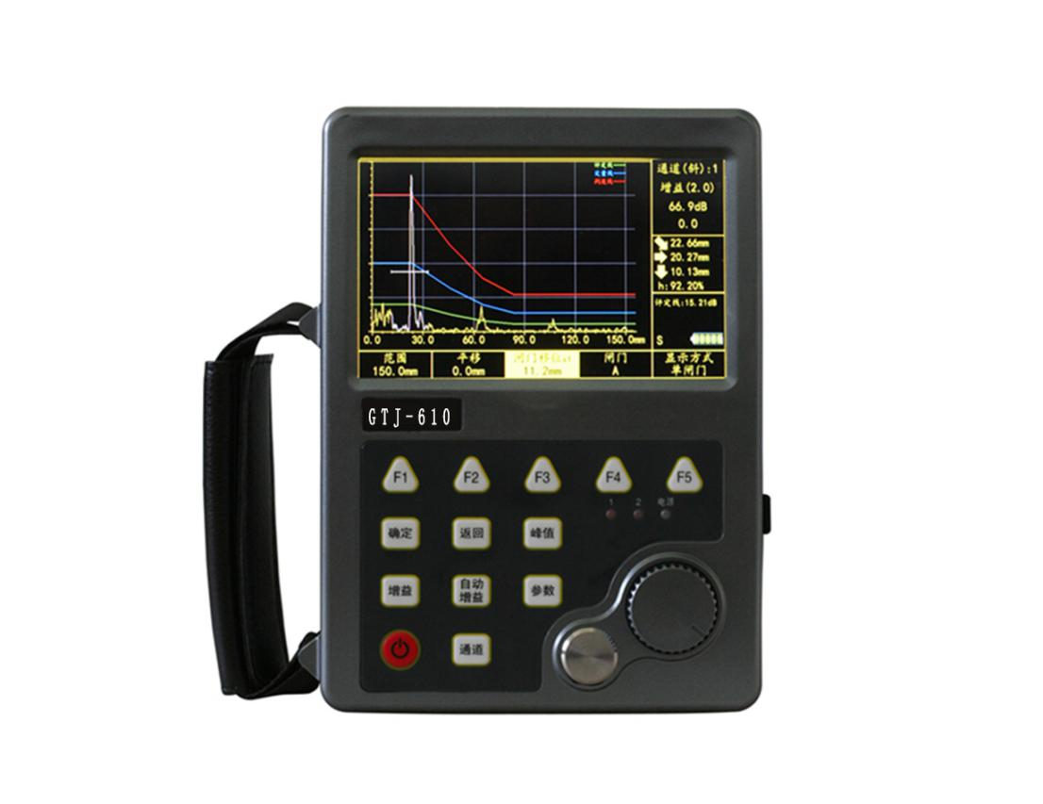
U600 Digital ultrasonic flaw detector
USAGE OVERVIEW
U600 Digital ultrasonic flaw detector and thickness measurement integrated machine integrated ultrasonic flaw detection, ultrasonic thickness measurement, and ultrasonic penetration functions in one. It has various functions such as ultrasonic thickness gauge, WIFI connection network or mobile phone, HDMI, digital filtering, etc., applicable Ultrasonic testing for the surface and internal defects of metal and non-metal materials in the industrial field. The design meets the requirement of ergonomics, and is simple, intuitive, convenient and practical. Provides a very high level of flaw detection with simple basic operations, which makes ultrasonic flaw detectors easy to use for both experienced and novice industry personnel.
U600 brings together modern high-tech such as ultrasonic flaw detection, thickness measurement, computer, electronics, mold, technology, etc., to achieve the perfect combination of these high-tech. It provides the industry with more superior performance and more powerful machines, which can be widely used in various fields such as petroleum, chemical industry, metallurgy, shipbuilding, aviation, and aerospace.
PRODUCT FEATURES
1.Ergonomically optimized design: small size and light weight, the overall size of the machine is 180 × 130 × 40mm, including the battery weight is only 0.75kg, it is extremely convenient to operate and carry;
2.Built-in domestic and foreign industry standards: The instrument has 11 national standards built-in, compatible with European standards.
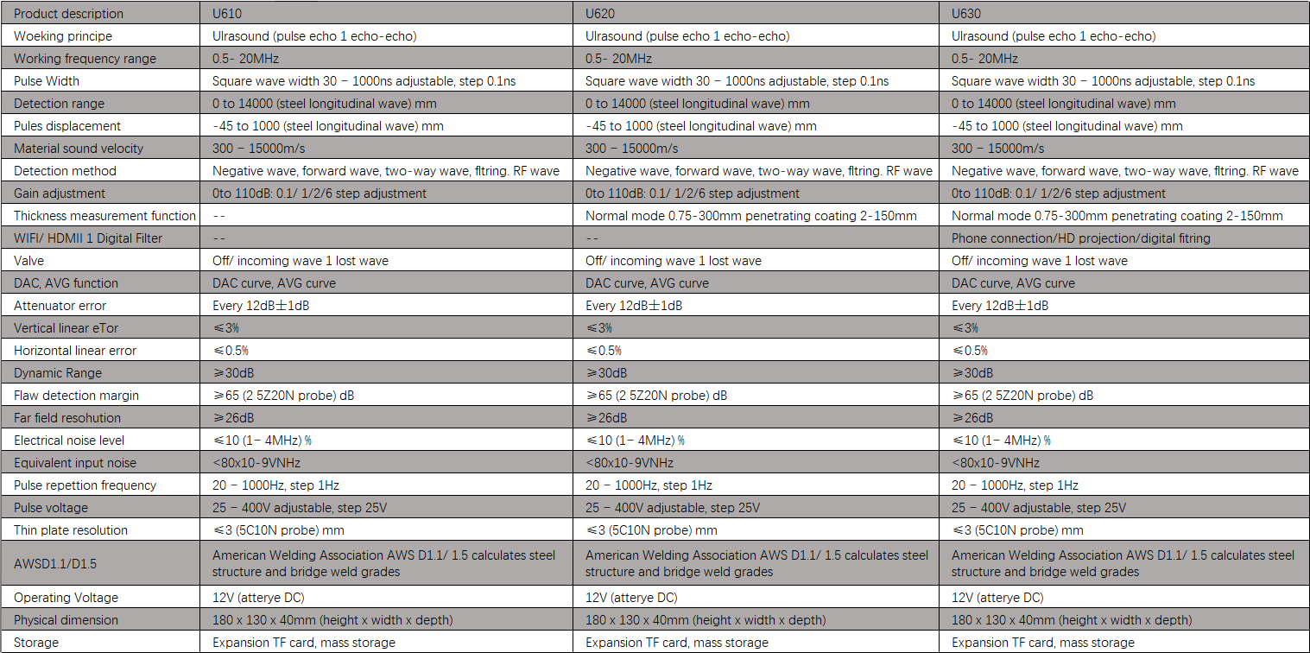
3.EN12668-1: 2010, which is convenient for setting various DAC and AVG curve parameters;
4.Accurate flaw detection High sensitivity: With digital filtering function, accurate selection of frequency bands, especially when detecting coarse grained materials such as castings, it can well filter out clutter, achieve intelligent analysis, and make small defects untouched;
5.High-precision thickness measurement Penetrable coating (U620 / 630): The instrument comes with a thickness gauge calibration test block. Has an independent thickness gauge operation software interface, thickness measurement accuracy is 0.01mm, and has a coating penetration function,
6.High-definition display Interface style can be adjusted: High-resolution 5.0-inch (800 × 480) widescreen true-color TFT LCD display, different interface styles, free switching between Chinese and English languages:
7.Recording function Mass data storage: It can record the flaw detection process and play back waveforms to realize digital storage and management of data. At the same time, it supports FT expansion to realize mass storage of flaw detection data;
8.HDMI interface Support for teaching use (U630): Through the HDMI interface, multimedia devices such as projectors can be connected, which is convenient for teaching and use in universities and research institutes;
9.WIFI communication Query flaw detection results anytime and anywhere (U630): With wireless network function, the instrument and mobile phone can be interconnected. The mobile phone can remotely access the instrument and query static storage files;
10.Low power consumption design Reliable function: Power-saving design, can work continuously for more than 10 hours, high-performance lithium battery module is easy to disassemble.
11.A variety of detection function modules: continuous storage function module, to achieve the full record of the scanning process waveform, especially suitable for the preservation, analysis and teaching demonstration of flaw detection data; time B scan function module to achieve rapid corrosion thickness measurement evaluation; AWS D1.1 professional Function module, suitable for steel structure welding seam inspection and evaluation.
12.A variety of detection operation functions :: peak memory function, real-time dynamic recording of the current wave top wave peak point information, instrument calibration flaw detection easily; the peak search function, the gate automatically searches for the peak, the detection operation is more convenient; the automatic gain function, the gate inside The amplitude automatically reaches 80%; waveform contrast function; waveform expansion function, real-time view echo details; with echo envelope function, to achieve advanced analysis of defect categories.
13.Automatic calibration function: automatic calibration of material sound velocity, probe delay, probe K value; convenient DAC and AVG curve production and application; DAC curve production embedded standards ASME, ASME III, JIS, EN1712, GB / T11345, NB / T47013.3 Such as domestic and foreign standards, and can customize up to 7 DAC curve parameters, which is very convenient for users to quickly select DAC curve parameters; DAC curve sensitivity query table function, convenient for students to view the sensitivity equivalent of the DAC curve, fill in the report; software operation Process design, automatic parameter adjustment, even beginners can quickly grasp the basic flaw detection operation methods.
14.Automatic test function: automatic test of instrument performance, convenient for users to quickly measure the instrument's important indicators such as horizontal linearity and vertical linearity.
Square wave excitation technology: Advanced square wave excitation technology has excellent penetrating power and signal-to-noise ratio for detecting high attenuation materials or thick workpieces; adjustable excitation pulse width, excitation voltage, and damping resistance enable detection of thin workpieces And composites have higher resolution.
TECHNICAL PARAMETERS

