U950/U960Non-metallic ultrasonic detector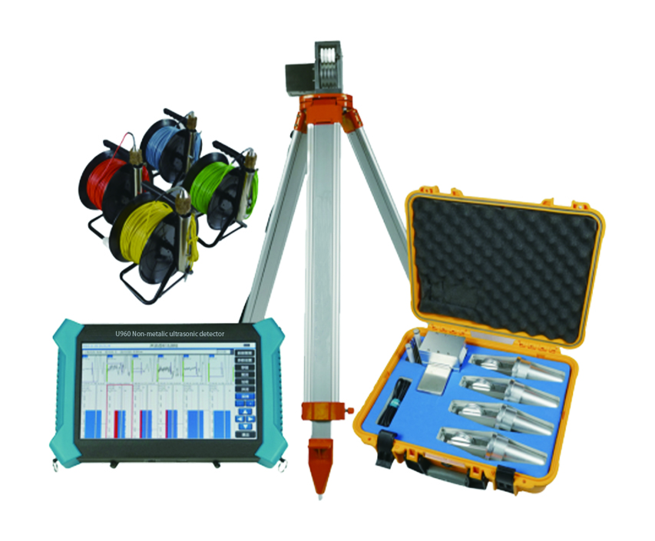
USAGE OVERVIEW
U950/U960Non-metallic ultrasonic detector(multi-tube measuring pile)Ultrasonic transmission method for pile integrity testing, Structural concrete compressive strength, crack depth, crack width and defect detection; Diaphragm wall integrity testing, which integrates five functions of pile testing, ultrasonic rebound comprehensive method for strength measurement, defect detection, crack sounding and width measurement. Geological exploration, rock integrity, weathering evaluation test; mechanical properties of non-metallic materials such as rock mass and concrete.

PRODUCT FEATURES
1.Newly upgraded wireless cloud transmission function;
2.With stable performance and powerful functions, it is the best choice for users with diverse needs such as engineering inspection, teaching and scientific research;
3.It integrates five functions of pile, strength measurement, defect measurement, sounding and width measurement.
4.Full touch screen operation, simple, convenient, stable and reliable;
5.Multichannel automatic acquisition, automatic recording of high harmony time waveform;
6.The deep recording wheel adopts dustproof and waterproof design;
7.Large memory capacity, working time up to 10 hours or more;
8.It can directly connect the digital rebound rifle probe to the ultrasonic rebound comprehensive method for measuring strength;
9.U disk dump data, support software upgrade through U disk;
10.The special analysis software has powerful functions, data analysis and processing, report generation and report printing can be easily completed.
11.The transducer spool is designed with a current collecting ring, and the signal cable is retractable to prevent the cable from being twisted.

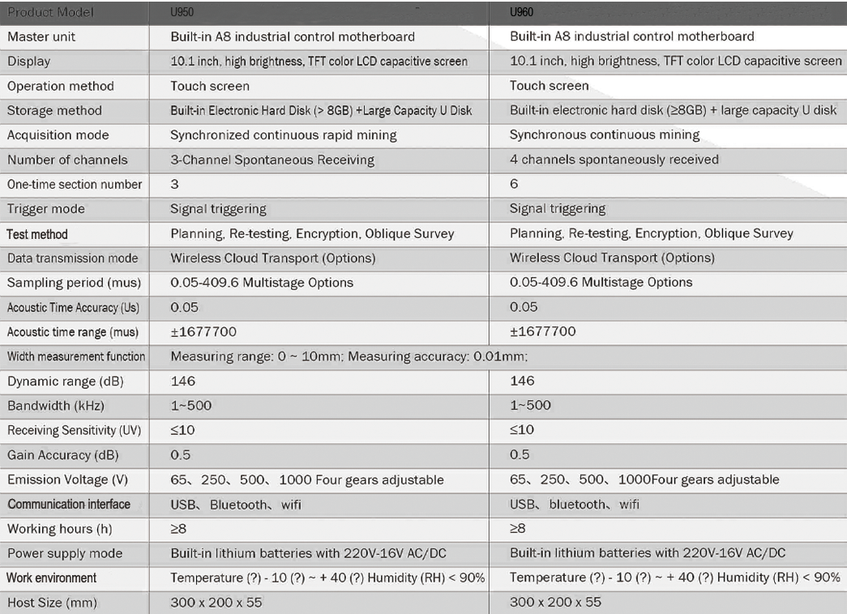
TECHNICAL PARAMETERS

