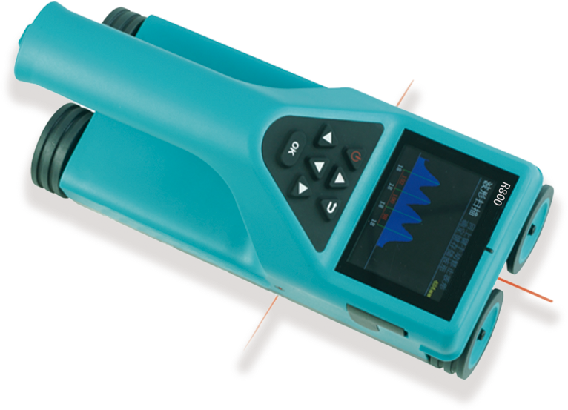
R800 Integrated rebar detector
USAGE OVERVIEW
The integrated rebar detector is a portable non-destructive testing instrument, which can be used to test the construction quality of reinforced concrete structures. It can measure the position of rebars on the concrete surface, detect the thickness of the steel protective layer and the diameter of the rebar. In addition, it can also magnetize the inside of the concrete structure. The position of the body and the conductor are detected, such as the internal cable of the wall and the plumbing pipe. The pre-construction detection can effectively avoid damage to these facilities during construction and reduce accidents.

PRODUCT FEATURES
1.Style design, compact size, light weight, easy to carry, new upgrade wireless cloud transmission function, laser precise positioning of steel bar position;
2.Thickness detection mode is intuitive, showing thickness and steel spacing at the same time.
3.Thickness detection mode can automatically store thickness and spacing, which greatly improves the detection efficiency. Waveform scanning mode shows the distribution of reinforcing bars intuitively, and it is more intuitive to detect and analyze dense reinforcing bars.
4.The waveform scanning mode also shows the thickness and spacing of the rebar protective layer.
5.It can detect the middle position of the two reinforcing bars, the aiming frame and the indication light, so as to facilitate drilling and coring.
6.The instrument automatically stores the calibration value, realizes fast measurement and avoids the trouble of each calibration.
7.Boundary-free mesh/profile scanning, the length of waveform scanning can reach 6m at a time.
8.TF card storage, large capacity, intuitive and convenient transmission;
9. 2.8 inch high resolution color liquid crystal screen;
10.PC professional data analysis software, data processing and report generation can be easily completed.

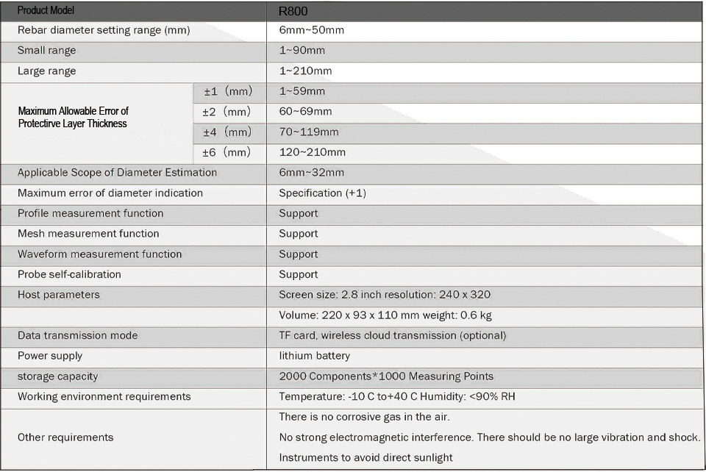
TECHNICAL PARAMETERS

