Evd Dynamic deformation modulus tester (hand-held drop hammer deflection tester)
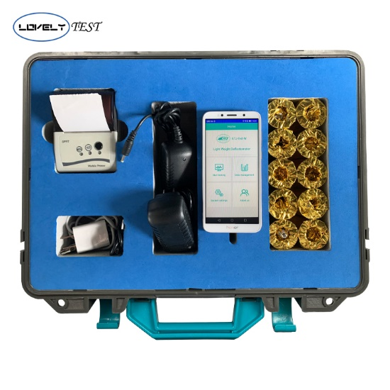
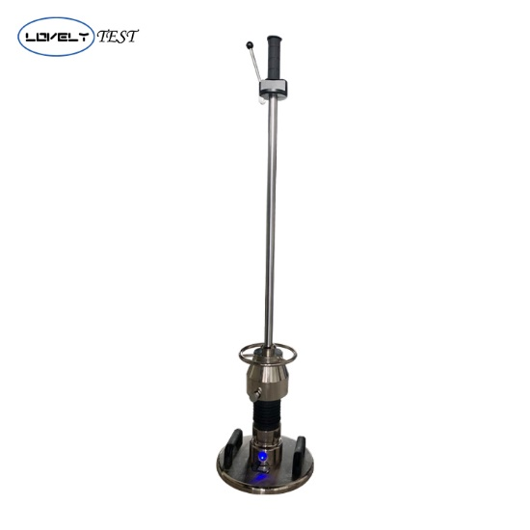

USAGE OVERVIEW
The GTJ-EVD-W type Light weight deflectometer is used to determine the deflection capacity of the subgrade under the dynamic load, thereby evaluating the bearing capacity and deformation of the subgrade. It is suitable for monitoring and testing the construction quality of railway, highway, airport, urban traffic, port, wharf and industrial and civil buildings under dynamic loads, especially in narrow areas, such as bridge (culvert) transition section and shoulder detection, existing line subgrade, etc. Compared with the static load test, the instrument can simulate the impact effect of high-speed train on subgrade, which can better reflect the actual stress of subgrade soil. It can quickly measure the dynamic deformation modulus Evd value.

PRODUCT FEATURES

- The first APP data processing method in China has realized wireless data acquisition, wireless transmission and voice prompt function.
- Provide a cloud transport port dockable engineering detection and management system to provide reliable data sources for real-time data acquisition, online data analysis, large data management, etc.
- Imported sensors and some components are used, which has high test accuracy and more reliable test data.
- The wireless Bluetooth micro printer can print directly on the spot to ensure the accuracy and objectivity of the test results.
- It is easy to operate and fast to test. It takes only 35 seconds to detect a point.
- The Evd value is calculated automatically and the curve is displayed accurately and intuitively.
- Non-nuclear radiation and exhaust gas pollution, safe operation and environmental protection.

Technical Parameter
Test coverage | Product Model | GTJ-EVD-W
 | Application Soil Types | Soil-rock mixed fillers with particle size less than 1/4of the diameter of loading plate
 | Test scope | 10Mpa≤Evd≤225Mpa
 | Test impact depth | 0~500mm
 | Work environment | Temperature: -10~40℃ Humidity: ＜90%HR
Work environment | Loading device | Weight: 15kg drop weight:10kg
 |  | Dropping height of drop hammer: 700±20mm
 |  | Maximum impact force: 7.07kN
 |  | Shock duration; 18±1ms
 | Loading plate | Weight:15kg Diameter: 300mm
 |  | Thickness: 20mm
Handheld host | Specifications | Screen size: 5 inches
 | Subsidence test range | Volume: 145x70x10mm
 |  | Weight: 110g
 | Storage capacity | 0.10mm~2.00mm
 |  | Depending on the memory of the phone, 10G storage capacity
 | Power supply mode | Depending on the cell phone battery
 | Display mode | Mobile App. English Display
 | Data transmission mode | Data wireless transmission, data cloud transmission
Printer | Connection mode | Wireless Bluetooth Printing
Packing specification | Host box | Material: Engineering plastics
 |  | Volume: 420x140x335mm
 |  | Weight: 4.5kg
 | Outer packing box | Material: Aluminum alloy
 |  | Volume: 1220x395x380mm
 |  | Weight: 56kg
