LOVELY-4114 Non-nuclear Soil Density Gauge
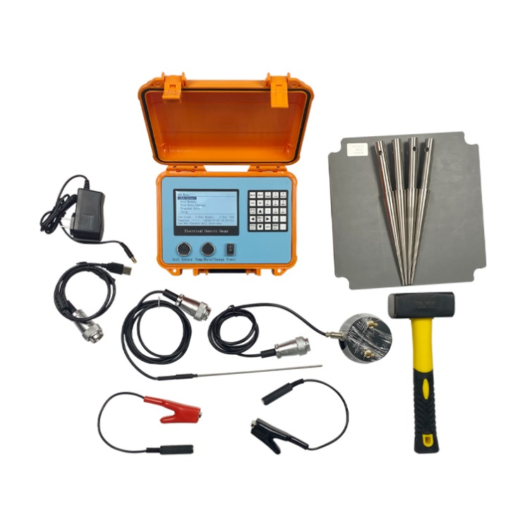
USAGE OVERVIEW
The LOVELY-4114 Non-nuclear soil density gauge (EDG) accurately measures soil density, moisture content and compaction in roads and foundations. The measurement accuracy depends mainly on the correct use of the operator, so a detailed reading of this operating manual will be available. Help you to use the product better.

Equipment Operation
Some new technologies that you need to be familiar with during the operation of EDG are introduced.
1. Soil model is the combination of soil electronic data and soil physical data input by users, and it is the basis of testing soil parameters in a similar soil characteristic area.
2. When making a soil model, EDG is needed to collect electronic signals at different test points (the test point of this soil model is called soil test). Each test point needs to collect an electronic signal. At the same time, sand cone test is needed to obtain the physical characteristics of the soil, such as wet density, dry density and moisture content. The maximum dry density of the soil is measured in the laboratory, and then these data are input into the instrument so that the electronic data can be correlated with the physical data.
3. At least three test points (soil test) are required for soil moulding. The more test points, the more representative the soil model will be. Moreover, the larger the density and water content range covered by the test points, the more accurate the soil model is.
4. After the soil model is made, EDG can be used for field test. The test area is the area where the experimenter intends to test and the tested soil has the same physical characteristics.
5. A soil model is usually made for each different test area. Different projects need different soil moulids. Once the soil model representing this area is successfully made, the soil characteristics of any test point can be quickly and accurately measured by EDG through field test.
6. The actual test is to calculate the physical properties of soil by comparing the electronic data collected from the test points with the soil model.
7. It could add GPS as requirments.
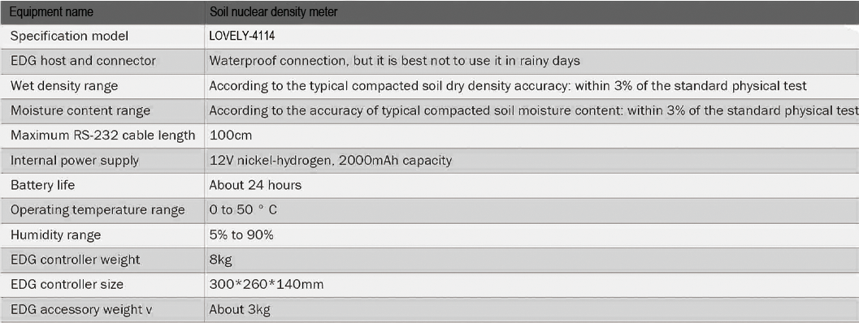
TECHNICAL PARAMETERS
