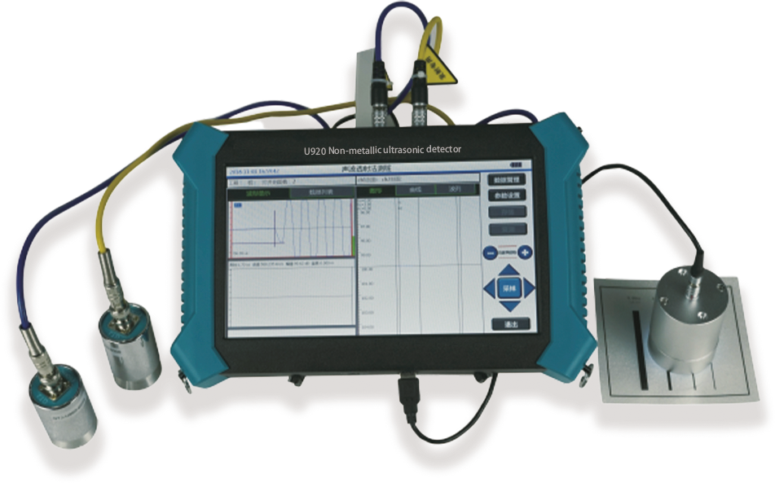
U910/U920Non-metallic ultrasonic detector
USAGE OVERVIEW
U910/U920 Non-metallic ultrasonic detector, structural concrete compressive strength, crack depth, crack width and defect detection; ultrasonic transmission method for detecting pile and continuous wall integrity. It integrates five functions of pile testing, ultrasonic rebound comprehensive method for strength measurement, defect measurement, crack sounding and width measurement. Geological exploration, rock integrity, weathering evaluation test; mechanical properties of non-metallic materials such as rock mass and concrete.
PRODUCT FEATURES
1.New upgraded wireless cloud transmission function;
2.Five functions of measuring pile, measuring strength, measuring defect, sounding depth and width measuring;
3.Stable performance and powerful function, it is the best choice for users with diverse needs such as engineering inspection, teaching and scientific research;
4.Semi-transparent, high-brightness, TFT color LCD screen;
5.Full touch screen operation, simple and convenient, stable and reliable;
6.Large memory capacity and working time of more than 10 hours;
7.It can be connected with the probe of digital display rebound instrument to measure the strength of ultrasonic rebound;
8.U-disk transfers data and supports software upgrading through U-disk;
9.Special analysis software is powerful, data analysis and processing, report generation, and report printing can be completed easily .
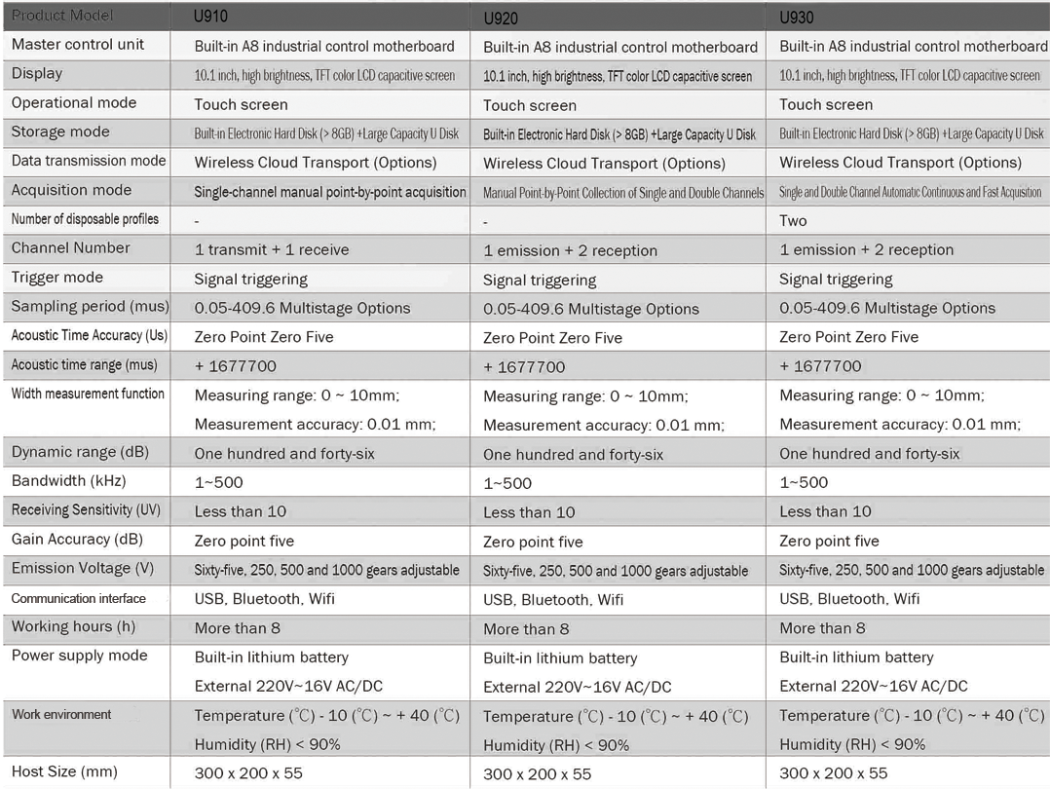
TECHNICAL PARAMETERS

