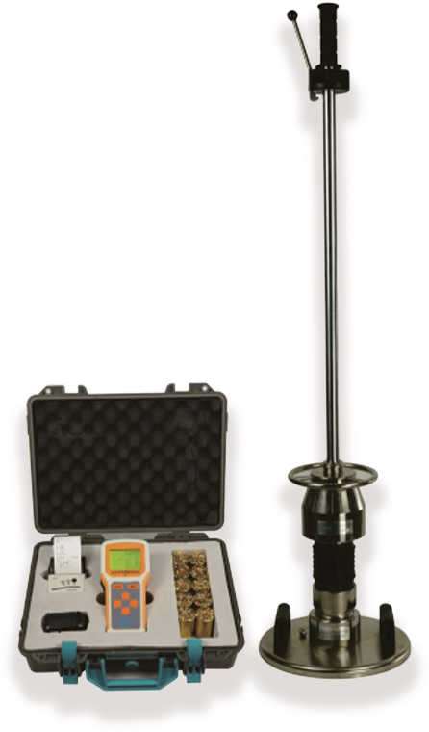
Evd Dynamic deformation modulus tester (hand-held drop hammer deflection tester)
USAGE OVERVIEW
Evd Light weight deflectometer is used to evaluate the deflection value of layered subgrade under dynamic load, so as to evaluate the bearing capacity and deformation of subgrade. lt is suitable for monitoring and testing the construction quality of railway, highway, airport, urban traffic, port, wharf and industrial and civil buildings under dynamic loads, especially in narrow areas, such as bridge (culvert) transition section and shoulder detection, existing line subgrade, etc. It can quickly measure the dynamic deformation modulus Evd value.

PRODUCT FEATURES
1.Imported sensors and parts of components are used to achieve high test accuracy.
2.LCD display in English and Chinese, with corresponding hints in Chinese and 3.English under different interfaces, and with backlight, has better visibility in various environments;
4.Easy to operate and fast to test It only takes 35 seconds to detect a point.
Automatically calculate Evd value and display curve, accurate and intuitive;
5.Hand-held mainframe with Bluetooth micro printer can print directly on the spot to ensure the accuracy and objectivity of the test results.
6.USB transmission interface, easy to connect with the computer;
7.The instrument simulates the impact effect of high-speed train on subgrade. Compared with static load test, it can better reflect the actual stress of subgrade soil.

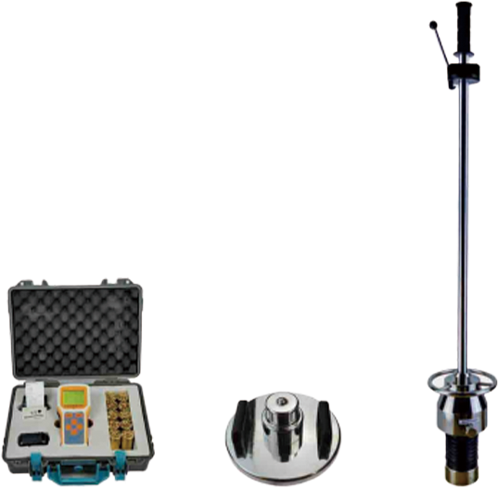
TECHNICAL PARAMETERS
Cable Evd mainframe Cable Load Plate Loading device

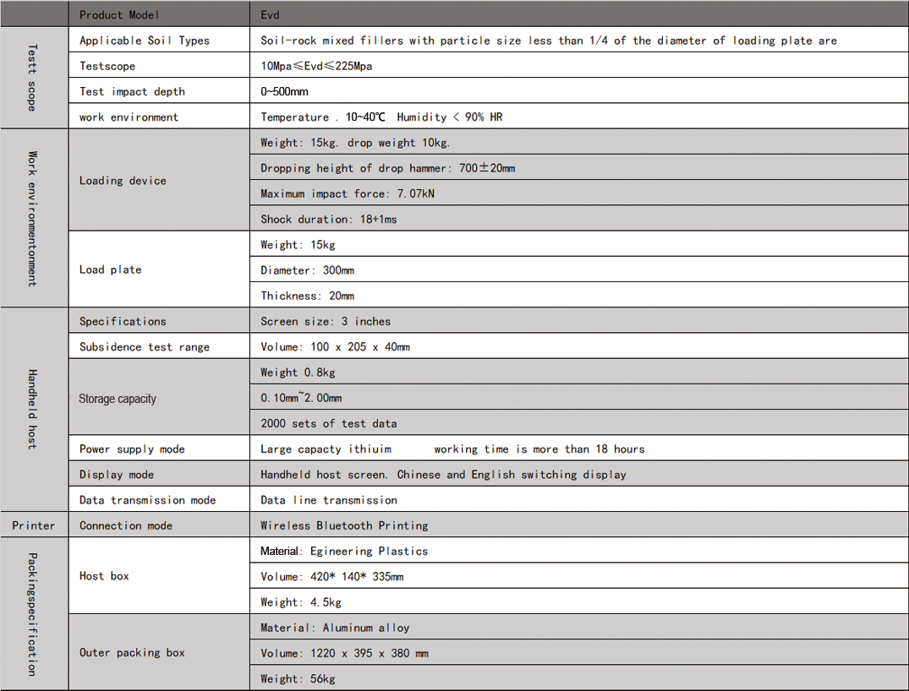
TECHNICAL PARAMETERS

