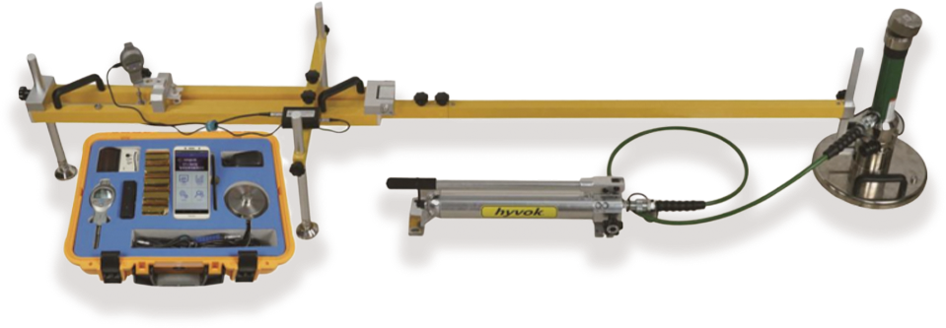
LOVELY-WK lntelligent ground vehicles tester
USAGE OVERVIEW
LOVELY-WK plate load test set can be used to test the foundation coefficient of coarse, fine soil and compacted roadbed, base course, etc. It can also be used to calculate the deformation modulus of uniform foundation soil. Test the stress and deformation characteristics of foundation soil, determine the foundation coefficient of railway, highway roadbed, base, etc. The product has the function of testing K30, K40, K60.ln order to meet the requirements of railway Informa ionization, our company jointly with experts of railway departments, breaking the traditional old test methods, intellectualized the foundation coefficient tester, greatly improving the test accuracy and efficiency. The product quality has reached the international advanced level.

PRODUCT FEATURES
1.It is the first data processing method of APP in China. It realizes data wireless collection and transmission. It also provides cloud transmission ports for docking engineering detection and management system. It provides reliable data sources for real-time data collection, online data analysis and large data management.
2.Imported sensors and some components are used, which has high test accuracy and more reliable test data.
3.Imported cylinders and manual pumps are adopted, with outstanding performance of pressure control and voltage stabilization.
4.The displacement acquisition device adopts heavy profile and three-point support design, which has strong seismic and windproof capability and ensures accurate data.
5.Displacement acquisition data: single point acquisition of load plate center, data more objective and accurate;
6.The wireless Bluetooth micro printer can print directly on the spot to ensure the accuracy and objectivity of the test results.
7.Direct display of load strength and settlement value, automatic calculation of K30, K40, K60 value, and display pressure and settlement curve.

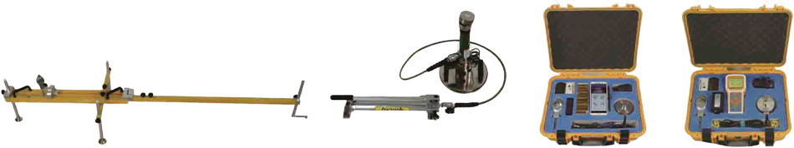
INSTRUMENT CONSYITUTES
Displacement measuring device Loading device Wireless Host Box Cable mainframe

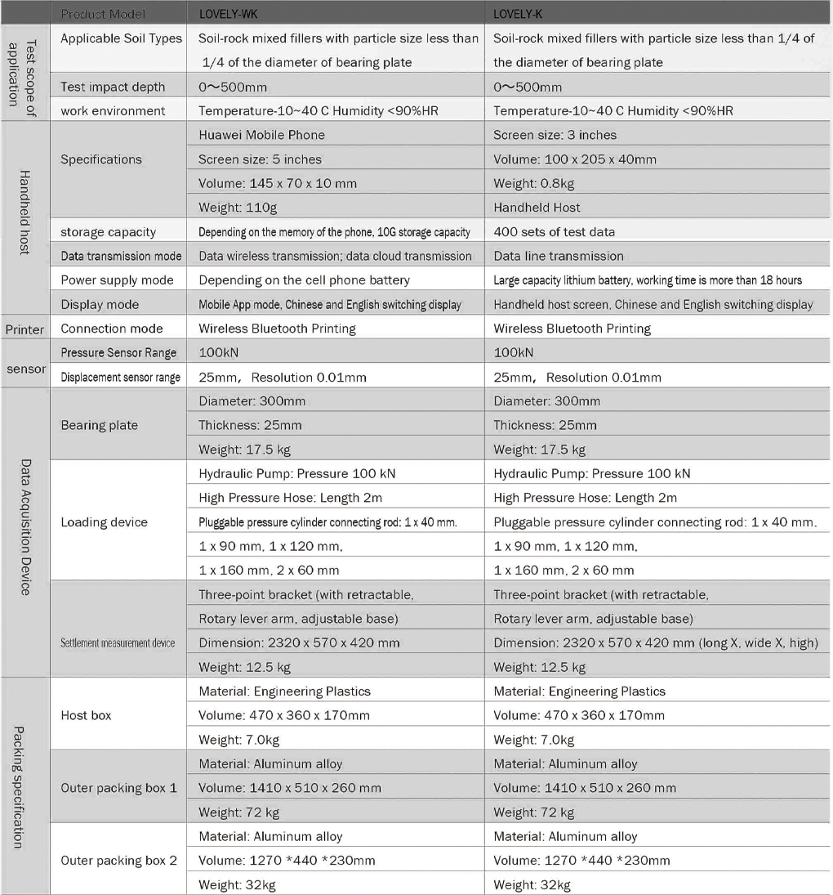
TECHNICAL PARAMETERS

