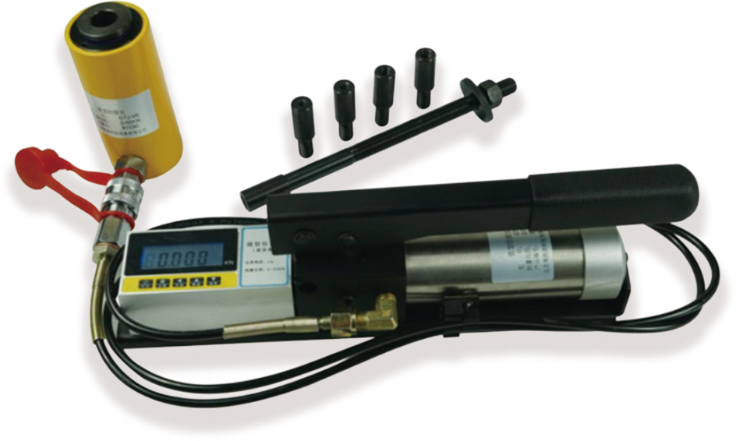
LOVELY-Vx Micro pull-out anchor tester
USAGE OVERVIEW
LOVELY-Vx Micro pull-out anchor tester is mainly used to detect, ∮6-∮12 masonry structure steel bar planting bar, M6-M12 expansion bolt, chemical anchor bolt, and various anchors' pull-out resistance. The on-site anti-pulling force test (test) of glass curtain wall is a necessary testing instrument for each (quality inspection unit, reinforcement unit, supervision unit, university, etc.).

PRODUCT FEATURES
1.Light weight. 2.6kg oil cylinder, 2.8kg smaller manual pump.
2.200 data records, query, LCD lighting function.
3.Peak hold, less than 4% unloading in 2 minutes, automatic shutdown without operation.
4.The 10-segment polyline correction of the value improves the accuracy of the instrument.
5.The power supply is a high-capacity rechargeable lithium battery and ultra-low power consumption design, and the continuous working time can exceed 200 hours.
6.Using imported seals, durable.
7.Corrosion-resistant electrostatic spraying on the surface of hydraulic cylinder, nickel-plated piston and sliding sleeve.
8.Overload protection structure is adopted, and the cylinder will not be damaged if it exceeds the range, so it can be used safely.

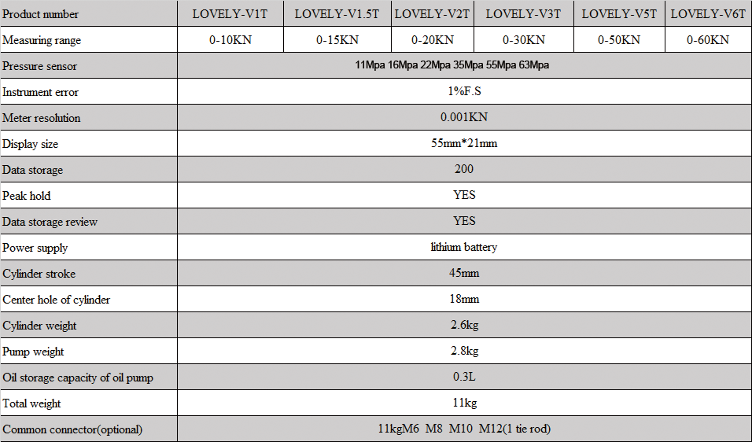
TECHNICAL PARAMETERS

