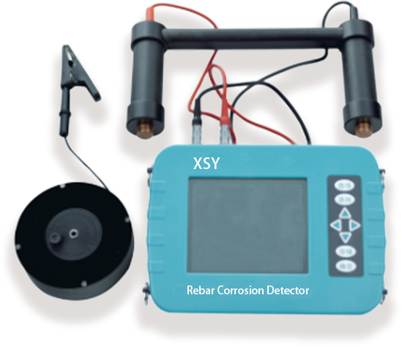
XSY Rebar Corrosion Detector
USAGE OVERVIEW
Corrosion of steel bars in structural concrete reduces the effective section area and enlarges the volume of steel bars, which leads to expansion, spalling of concrete, reduction of bonding force and bearing capacity between steel bars and concrete, and directly affects the safety and durability of concrete structures. Therefore, the detection of steel corrosion in concrete structures is an important part of the safety assessment and appraisal of existing buildings.

PRODUCT FEATURES
1.New upgrade, three - proof shell design, waterproof, dustproof, shockproof;
2.XSY debar corrosion detector adopts the polarization electrode principle and measures the surface potential of concrete through the copper/copper sulfate reference electrode. It judges whether the steel is corroded and the degree of corrosion according to the potential size generated by the steel corrosion or the potential gradient formed.
3.Measure the surface potential of concrete so as to achieve the non-destructive testing of corrosion degree of steel reinforcement in concrete;
4.Store the potential value at the corresponding position of each measurement area and display it graphically, and transfer the data to the upper computer software, and operate on it.

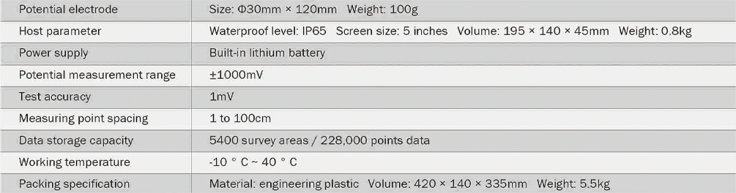
TECHNICAL PARAMETERS

